EXPERIMENT-1

|  |  |
| --- | --- |
| Name | Adwait Purao |
| UID | 2021300101 |
| Experiment No. | 1 |
| Batch | B2 |
| Course | Artificial Intelligence & Machine Learning |
| Faculty | Prof. Swapnali Kurhade |

**Problem Definition:** 1) Missionaries and Cannibal Problem: In the missionaries and Cannibals problem, three missionaries and three cannibals must cross a river using a boat which can carry at most two people, under the constraint that, for both banks, if there are missionaries present on the bank, they cannot be outnumbered by cannibals (if they were, the cannibals would eat the missionaries). The boat cannot cross the river by itself with no people on board.

**Theory:** The Missionaries and Cannibals problem is a well-known toy problem in artificial intelligence, where it was used by Saul Amarel as an example of problem representation. Suppose the missionaries and cannibals wants to move from left island to right island the following are the steps to solve the problem:

1. Move 2 cannibals from right to left
2. Move 1 cannibal from left to right
3. Move 2 cannibals from right to left
4. Move 1 cannibal from left to right
5. Move 2 missionaries from right to left
6. Move 1 cannibal and 1 missionary from left to right
7. Move 2 missionaries from right to left
8. Move 1 cannibal from left to right
9. Move 2 cannibals from right to left
10. Move 1 cannibal from left to right
11. Finally, move 2 cannibals from right to left

Using the above steps, user can move all 3 cannibals and 3 missionaries from right to left island without violating any of the constraints.

**Code:**

print("-------------------------------------------Missionary & Cannibal Problem---------------------------------------")

rm = 3

rc = 3

lm = 0

lc = 0

um = 0

uc = 0

while True:

    if lm == 3 and lc == 3:

        print("Congratulations, you won!!!")

        break

    else:

        um = int(input("Enter the number of missionaries traveling from right to left: "))

        uc = int(input("Enter the number of cannibals traveling from right to left: "))

        if (um + uc) > 2 or (um + uc) <= 0:

            print("Boat can contain maximum 2 members and minimum 1 member. Boat cannot be empty")

            continue

        elif (rm - um < 0):

            print("There are less number of missionaries on the right than entered")

            continue

        elif (rc - uc < 0):

            print("There are less number of cannibals on the right than entered")

            continue

        elif (um == 0 and uc == 0):

            print("Boat must contain atleast 1 missionary or cannibal")

            continue

        elif (um < 0 or uc < 0):

            print("Negative numbers not allowed")

            continue

        rm -= um

        rc -= uc

        lm += um

        lc += uc

        print("Missionaries on right: ",rm)

        print("Cannibals on right: ",rc)

        print("Missionaries on left: ",lm)

        print("Cannibals on left: ",lc)

        if (lm > 0 and lm < lc) or (rm > 0 and rm < rc):

            print("Cannibals ate missionaries. You lost")

            break

        if lm == 3 and lc == 3:

            print("-------------------------------------------Congratulations, you won---------------------------------------")

            break

        um = int(input("Enter the number of missionaries traveling from left to right: "))

        uc = int(input("Enter the number of cannibals traveling from left to right: "))

        if (um + uc) > 2 or (um + uc) <= 0:

            print("Boat can contain maximum 2 members and minimum 1 member. Boat cannot be empty")

            continue

        elif (lm - um < 0):

            print("There are less number of missionaries on the right than entered")

            continue

        elif (lc - uc < 0):

            print("There are less number of cannibals on the right than entered")

            continue

        elif (um == 0 and uc == 0):

            print("Boat must contain atleast 1 missionary or cannibal")

            continue

        elif (um < 0 or uc < 0):

            print("Negative numbers not allowed")

            continue

        rm += um

        rc += uc

        lm -= um

        lc -= uc

        print("Missionaries on right: ",rm)

        print("Cannibals on right: ",rc)

        print("Missionaries on left: ",lm)

        print("Cannibals on left: ",lc)

        if (rm > 0 and rc > rm) or (lm > 0 and lc >  lm):

            print("Cannibals ate missionaries. You lost")

            break

**Output:**

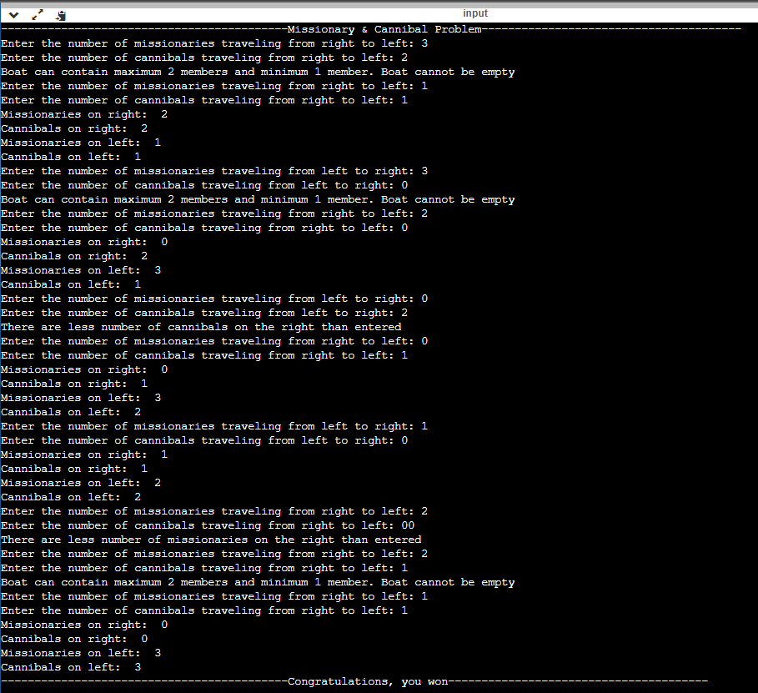

**Problem Definition: 2)** Water Jug ProblemYou are given two jugs, a 4-liter one and a 3-liter one. Neither has any measuring markers on it. There is a pump that can be used to fill the jugs with water. How can you get exactly 2 liters of water in either of jug.

**Theory:** Given two water jugs with capacities 4 and 3 litres. Initially, both the jugs are empty. Also given that there is an infinite amount of water available. The jugs do not have markings to measure smaller quantities. One can perform the following operations on the jug:

1. Fill Jug 1 completely (4 ltr)

2. Fill Jug 2 completely (3 ltr

3. Transfer water from Jug 1 to Jug 2

4. Transfer water from Jug 2 to Jug 1

5. Empty Jug 1

6. Empty Jug

The task is to determine whether it is possible to measure 2 litres of water using both jugs.

The following is the solution to find the answer for the above problem:

* Fill the 4-litre jug completely with water.
* Empty water from 4-litre jug into 3-litre (leaving 1L water in 4L jug and 3L completely full).
* Empty water from 3L.
* Pour water from 4L jug into 3L jug (4L being completely empty and 1L water in 3L litre jug)
* Fill the 4L jug with water completely again.
* Transfer water from 4L jug to 3L jug, resulting in 2L water in 4L jug.

**Code:**

print("-------------------------Welcome To jug problem---------------------------")

print("Given two water jugs with capacities 4 and 3 litres. Initially, both the jugs are empty. Also given that there is an infinite amount of water available. The jugs do not have markings to measure smaller quantities. One can perform the following operations on the jug:")

print("1. Fill Jug 1 completely (4 ltr)")

print("2. Fill Jug 2 completely (3 ltr)")

print("3. Transfer water from Jug 1 to Jug 2")

print("4. Transfer water from Jug 2 to Jug 1")

print("5. Empty Jug 1")

print("6. Empty Jug 2")

print("The task is to determine whether it is possible to measure 2 litres of water using both jugs.")

jug1 = 0

jug2 = 0

while True:

    if jug1 == 2 or jug2 == 2:

        print("Congratulations!!! You won")

        break

    else:

        print("Select Your Option: ")

        choice = int(input())

        match choice:

            case 1:

                jug1 = 4

                print("JUG1: ",jug1," JUG2: ", jug2)

            case 2:

                jug2 = 3

                print("JUG1: ",jug1," JUG2: ", jug2)

            case 3:

                while(jug1 >0 and jug2<3):

                    jug1-=1

                    jug2+=1

                print("JUG1: ",jug1," JUG2: ", jug2)

            case 4:

                while(jug2 >0 and jug1<4):

                    jug2-=1

                    jug1+=1

                print("JUG1: ",jug1," JUG2: ", jug2)

            case 5:

                jug1 = 0

                print("JUG1: ",jug1," JUG2: ", jug2)

            case 6:

                jug2 = 0

                print("JUG1: ",jug1," JUG2: ", jug2)

**Output**

**Conclusion**

The task of writing Python code to solve the Missionary and Cannibals problem and the Water Jug problem has been an great learning experience. It has offered a hands-on approach to understanding the application of programming logic and algorithms in solving complex problems. This practical task has guided me through a step-by-step process of solving problems that have numerous constraints. Overall, these exercises have not only enhanced my Python programming skills but also improved my problem-solving abilities.